Algorithm Analysis Fundamentals
Time complexity analysis of iterative and recursive algorithms; verify Big-O, Ω, Θ for sample programs
Dr. M.Manikandan

Experiment 1: Linear Search (Iterative)
- Objective: To analyze time complexity of linear search.
- Problem Statement: Write a Python program to search for a key in an array using linear search.
- Sample Input: [10, 25, 30, 45, 50], Key = 30
- Sample Output: Key found at index 2
- Complexity: Ω: O(1), O: O(n), Θ: Θ(n)
- Explanation: Demonstrates sequential scanning and inefficiency for large inputs.

Experiment 2: Binary Search (Recursive)
- Objective: To compare recursive binary search complexity.
- Problem Statement: Implement recursive binary search in Python.
- Sample Input: [5, 10, 15, 20, 25], Key = 20
- Sample Output: Key found at index 3
- Complexity: Ω: O(1), O: O(log⁡n), Θ: Θ(log⁡n)
- Explanation: Shows divide-and-conquer and logarithmic efficiency.

Experiment 3: Factorial (Iterative vs Recursive)
- Objective: To compare iterative and recursive factorial computation.
- Problem Statement: Write programs to compute factorial using both methods.
- Sample Input: n = 5
- Sample Output: 120
- Complexity: Both O(n)
- Explanation: Highlights recursion depth vs iterative loops.

Experiment 4: Fibonacci Series
- Objective: To analyze recursive vs iterative Fibonacci generation.
- Problem Statement: Generate first n Fibonacci numbers.
- Sample Input: n = 6
- Sample Output: [0, 1, 1, 2, 3, 5]
- Complexity: Iterative O(n), Recursive naïve O(2n), Recursive with memoization O(n)
- Explanation: Illustrates exponential recursion vs efficient iteration.

Experiment 5: Matrix Multiplication
- Objective: To analyze nested loop complexity.
- Problem Statement: Multiply two matrices using loops.
- Sample Input: A=[[1,2],[3,4]], B=[[5,6],[7,8]]
- Sample Output: [[19,22],[43,50]]
- Complexity: O(n3)
- Explanation: Shows cubic growth due to nested loops.

Experiment 6: Merge Sort
- Objective: To analyze divide-and-conquer sorting.
- Problem Statement: Implement merge sort.
- Sample Input: [38, 27, 43, 3, 9, 82, 10]
- Sample Output: [3, 9, 10, 27, 38, 43, 82]
- Complexity: Always O(nlog⁡n)
- Explanation: Demonstrates guaranteed efficiency of divide-and-conquer.

Experiment 7: Quick Sort
- Objective: To analyze recursive quick sort.
- Problem Statement: Implement quick sort.
- Sample Input: [10, 7, 8, 9, 1, 5]
- Sample Output: [1, 5, 7, 8, 9, 10]
- Complexity: Ω: O(nlog⁡n), O: O(n2), Θ: Θ(nlog⁡n)
- Explanation: Shows how pivot choice affects performance.

Experiment 8: Tower of Hanoi
- Objective: To analyze exponential recursion.
- Problem Statement: Solve Tower of Hanoi for n disks.
- Sample Input: n = 3
- Sample Output: Sequence of moves.
- Complexity: O(2n)
- Explanation: Illustrates exponential growth in recursive calls.

Experiment 9: GCD (Euclidean Algorithm)
- Objective: To analyze recursive GCD.
- Problem Statement: Implement Euclidean algorithm.
- Sample Input: a=48, b=18
- Sample Output: 6
- Complexity: O(log⁡n)
- Explanation: Shows efficient recursion with logarithmic complexity.

Experiment 10: Insertion Sort
- Objective: To analyze iterative sorting.
- Problem Statement: Implement insertion sort.
- Sample Input: [12, 11, 13, 5, 6]
- Sample Output: [5, 6, 11, 12, 13]
- Complexity: Ω: O(n), O: O(n2), Θ: Θ(n2)
- Explanation: Demonstrates input sensitivity (sorted vs unsorted).

Experiment 11: Heap Sort
- Objective: To analyze heap-based sorting.
- Problem Statement: Implement heap sort.
- Sample Input: [4, 10, 3, 5, 1]
- Sample Output: [1, 3, 4, 5, 10]
- Complexity: Always O(nlog⁡n)
- Explanation: Consistent performance using heap structure.

Experiment 12: Counting Inversions
- Objective: To analyze modified merge sort.
- Problem Statement: Count inversions in an array.
- Sample Input: [2, 4, 1, 3, 5]
- Sample Output: 3
- Complexity: O(nlog⁡n)
- Explanation: Shows divide-and-conquer applied beyond sorting.

Experiment 13: Maximum Subarray Sum
- Objective: To compare Kadane’s vs divide-and-conquer.
- Problem Statement: Find maximum subarray sum.
- Sample Input: [-2, -3, 4, -1, -2, 1, 5, -3]
- Sample Output: 7
- Complexity: Kadane’s O(n), Divide & Conquer O(nlog⁡n)
- Explanation: Highlights efficiency differences between approaches.

Experiment 14: Exponentiation
- Objective: To compare iterative vs recursive fast power.
- Problem Statement: Compute xn.
- Sample Input: x=2, n=10
- Sample Output: 1024
- Complexity: Iterative O(n), Recursive fast power O(log⁡n)
- Explanation: Shows how recursion reduces complexity.

Experiment 15: Closest Pair of Points
- Objective: To analyze brute force vs divide-and-conquer.
- Problem Statement: Find closest pair of points in 2D.
- Sample Input: [(1,2), (4,5), (7,8), (3,1)]
- Sample Output: Closest pair (1,2)-(3,1), Distance = √5
- Complexity: Brute force O(n2), Optimized O(nlog⁡n)
- Explanation: Demonstrates quadratic complexity and motivates optimization.

Exp 1:
arr = [10, 25, 30, 45, 50]
key = 30

found = False

for i in range(len(arr)):
if arr[i] == key:
print("Key found at index", i)
found = True
break

if not found:
print("Key not found")
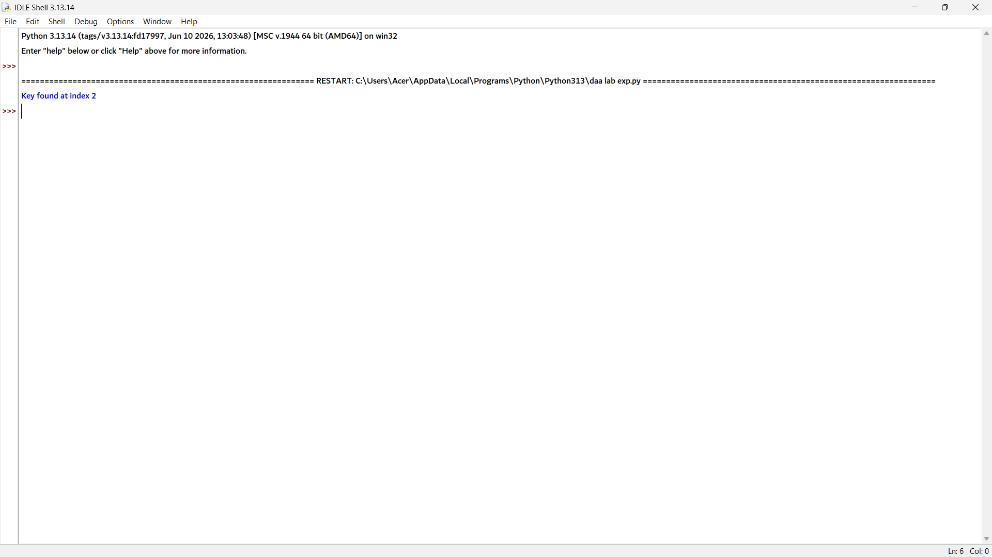

Exp 2:
def binary_search(arr, low, high, key):
if low <= high:
mid = (low + high) // 2

if arr[mid] == key:
return mid
elif key < arr[mid]:
return binary_search(arr, low, mid - 1, key)
else:
return binary_search(arr, mid + 1, high, key)

return -1

arr = [5, 10, 15, 20, 25]
key = 20

result = binary_search(arr, 0, len(arr) - 1, key)

if result != -1:
print("Key found at index", result)
else:
print("Key not found")
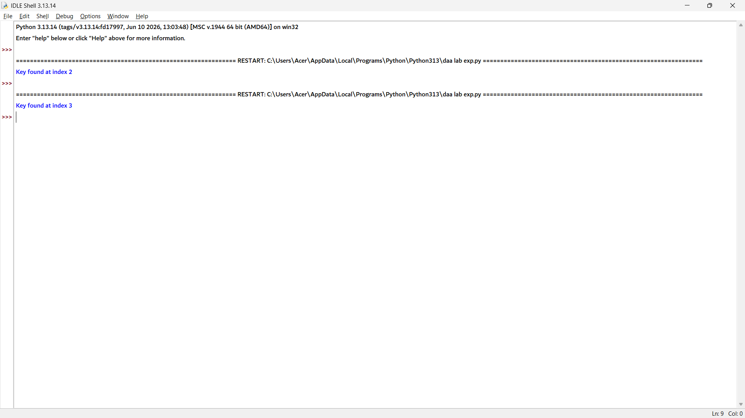

Exp 3:
# Iterative Method
def factorial_iterative(n):
fact = 1
for i in range(1, n + 1):
fact = fact * i
return fact

# Recursive Method
def factorial_recursive(n):
if n == 0 or n == 1:
return 1
return n * factorial_recursive(n - 1)

n = 5

print("Iterative Factorial:", factorial_iterative(n))
print("Recursive Factorial:", factorial_recursive(n))

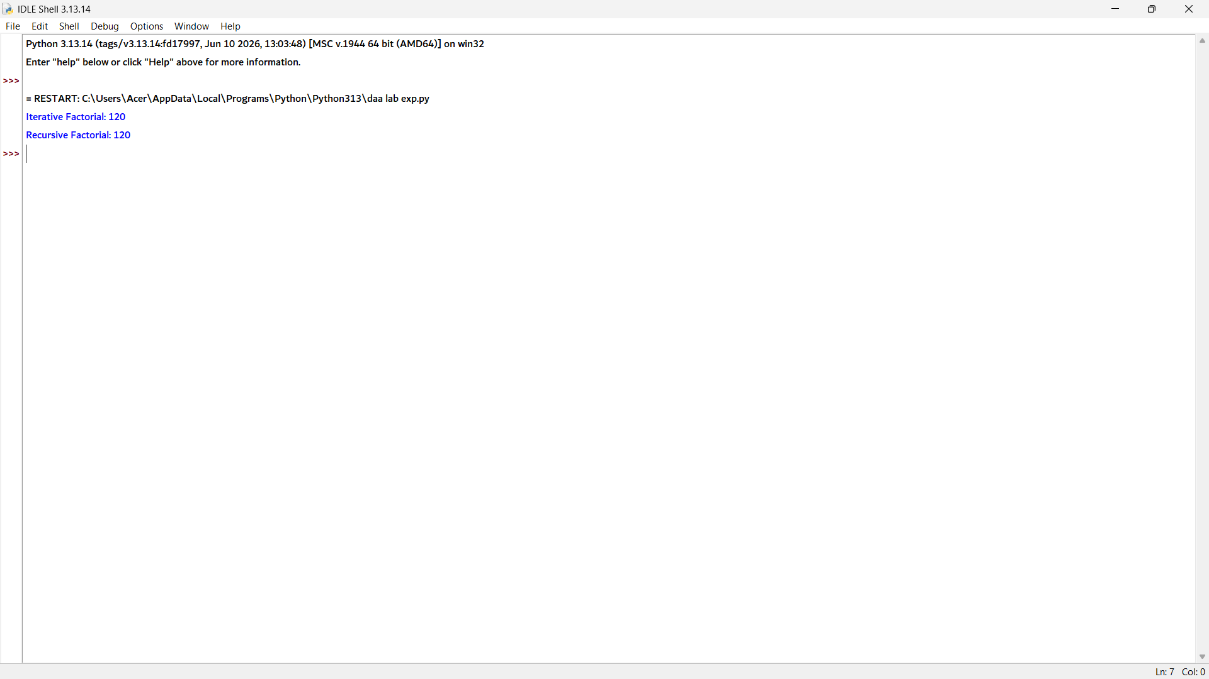

Exp 4:
# Iterative Method
def fibonacci_iterative(n):
a, b = 0, 1
for i in range(n):
print(a, end=" ")
a, b = b, a + b

# Recursive Method
def fibonacci_recursive(n):
if n <= 1:
return n
return fibonacci_recursive(n - 1) + fibonacci_recursive(n - 2)

n = 6

print("Iterative Fibonacci:")
fibonacci_iterative(n)

print("\nRecursive Fibonacci:")
for i in range(n):
print(fibonacci_recursive(i), end=" ")

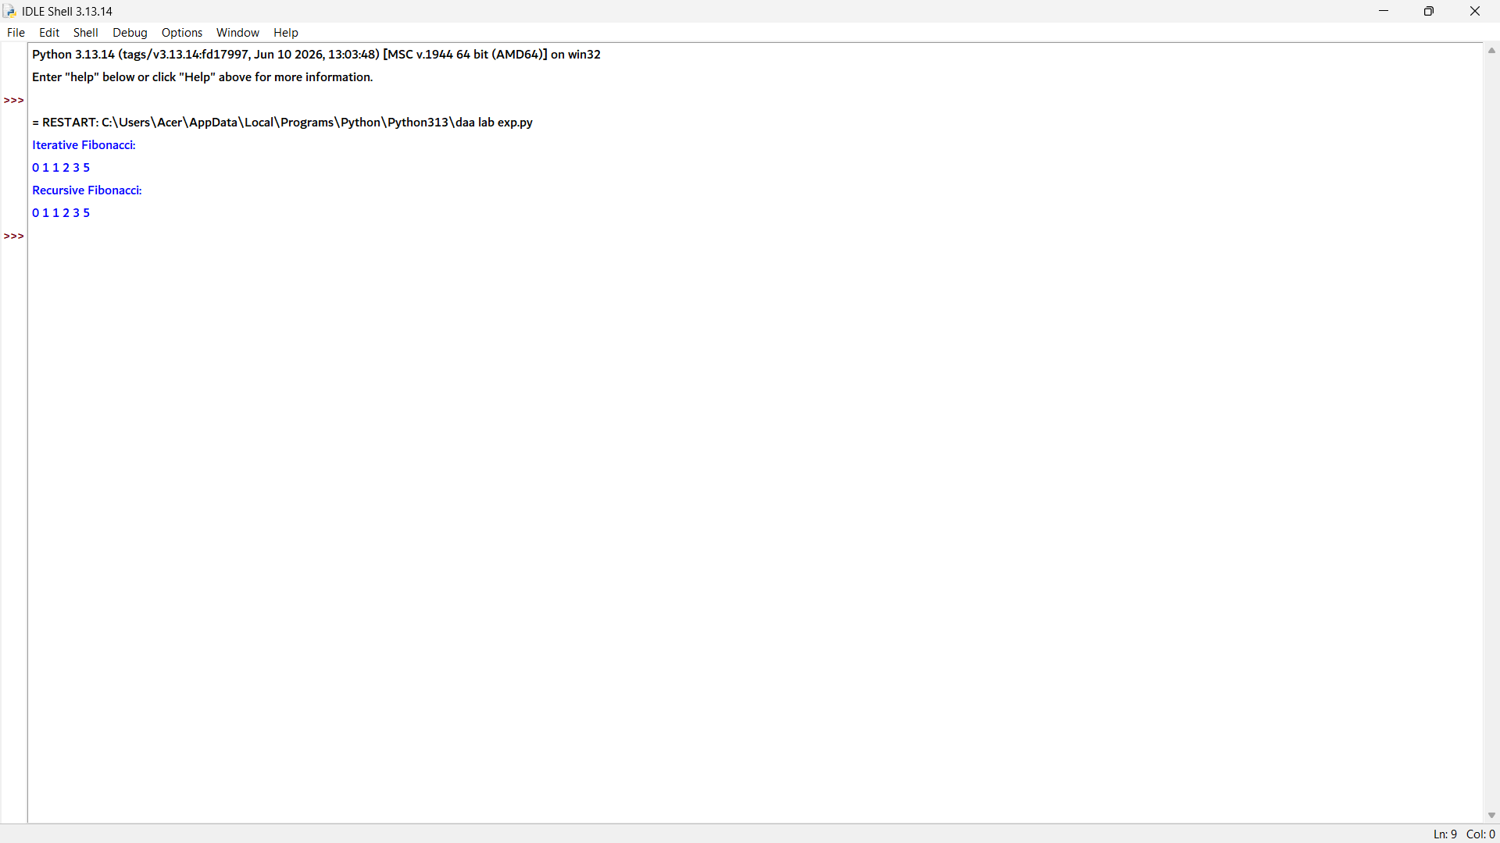

Exp 5:
A = [[1, 2],
[3, 4]]

B = [[5, 6],
[7, 8]]

result = [[0, 0],
[0, 0]]

for i in range(len(A)):
for j in range(len(B[0])):
for k in range(len(B)):
result[i][j] += A[i][k] * B[k][j]

print("Resultant Matrix:")
for row in result:
print(row)

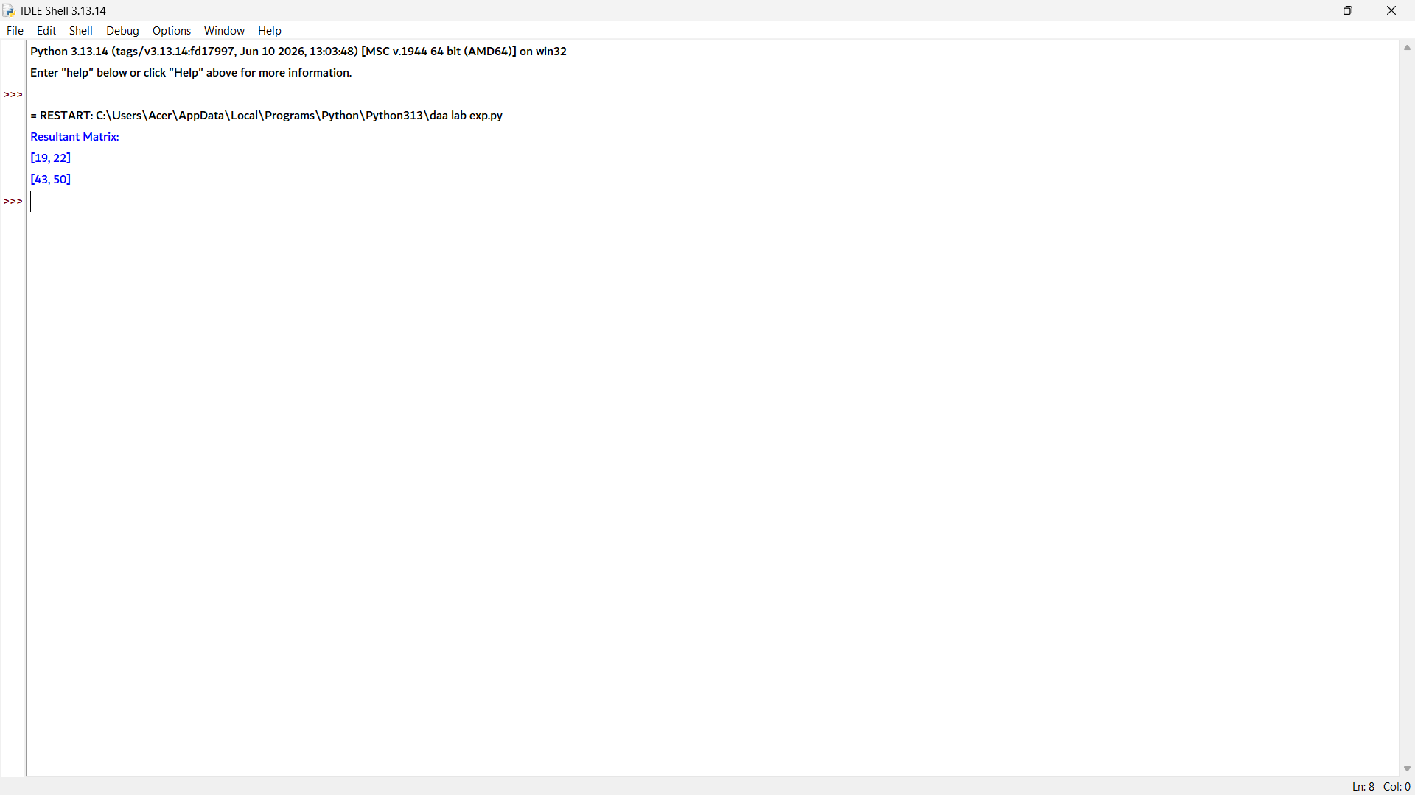

Exp 6:
def merge_sort(arr):
if len(arr) > 1:
mid = len(arr) // 2

left = arr[:mid]
right = arr[mid:]

merge_sort(left)
merge_sort(right)

i = j = k = 0

while i < len(left) and j < len(right):
if left[i] < right[j]:
arr[k] = left[i]
i += 1
else:
arr[k] = right[j]
j += 1
k += 1

while i < len(left):
arr[k] = left[i]
i += 1
k += 1

while j < len(right):
arr[k] = right[j]
j += 1
k += 1

arr = [38, 27, 43, 3, 9, 82, 10]

merge_sort(arr)

print("Sorted Array:", arr)
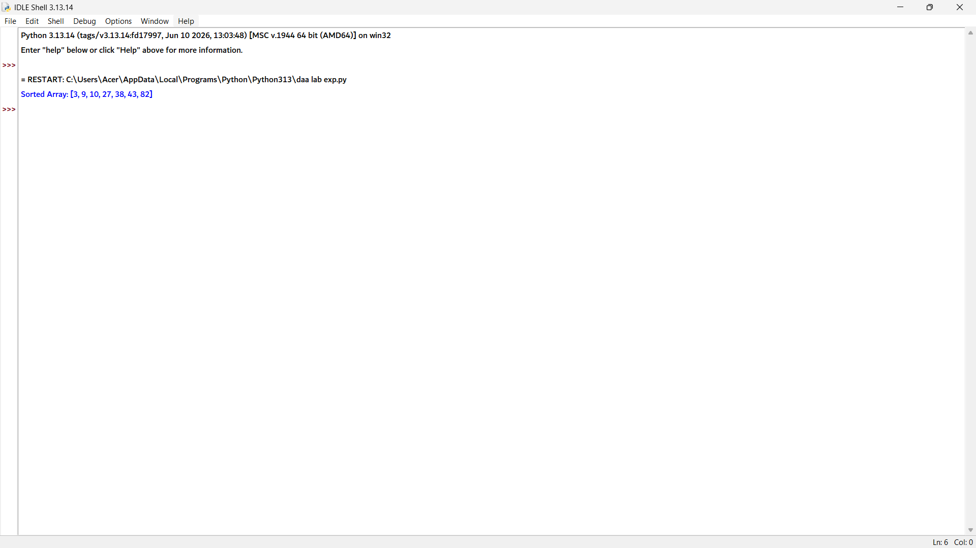

Exp 6;
def quick_sort(arr):
if len(arr) <= 1:
return arr

pivot = arr[0]
left = []
right = []

for i in arr[1:]:
if i <= pivot:
left.append(i)
else:
right.append(i)

return quick_sort(left) + [pivot] + quick_sort(right)

arr = [10, 7, 8, 9, 1, 5]

print("Sorted Array:", quick_sort(arr))

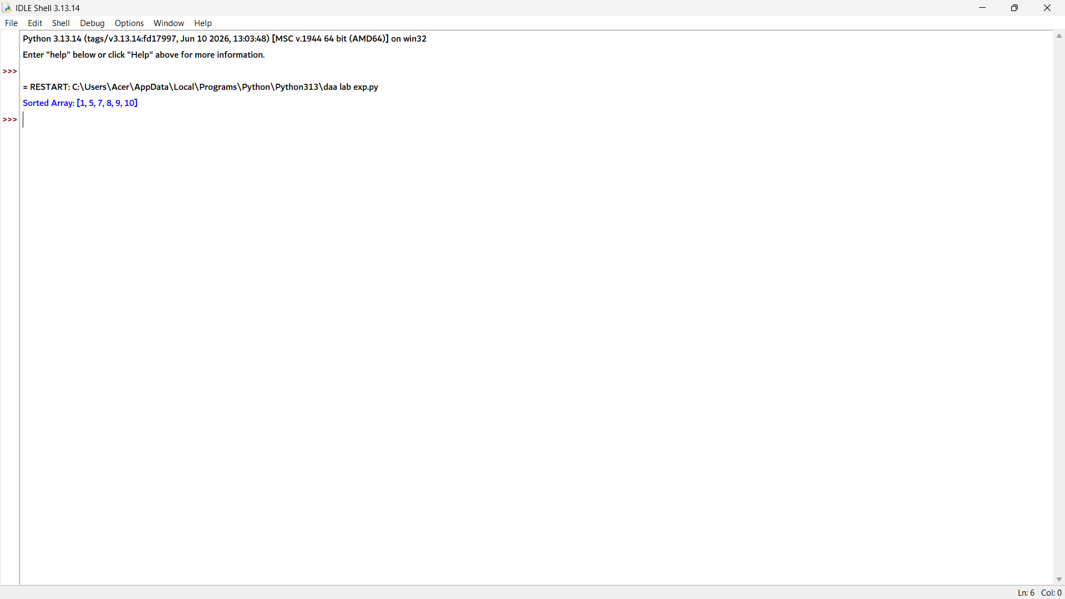

Exp 8:

def tower_of_hanoi(n, source, auxiliary, destination):
if n == 1:
print("Move disk 1 from", source, "to", destination)
return

tower_of_hanoi(n - 1, source, destination, auxiliary)
print("Move disk", n, "from", source, "to", destination)
tower_of_hanoi(n - 1, auxiliary, source, destination)

n = 3

tower_of_hanoi(n, "A", "B", "C")

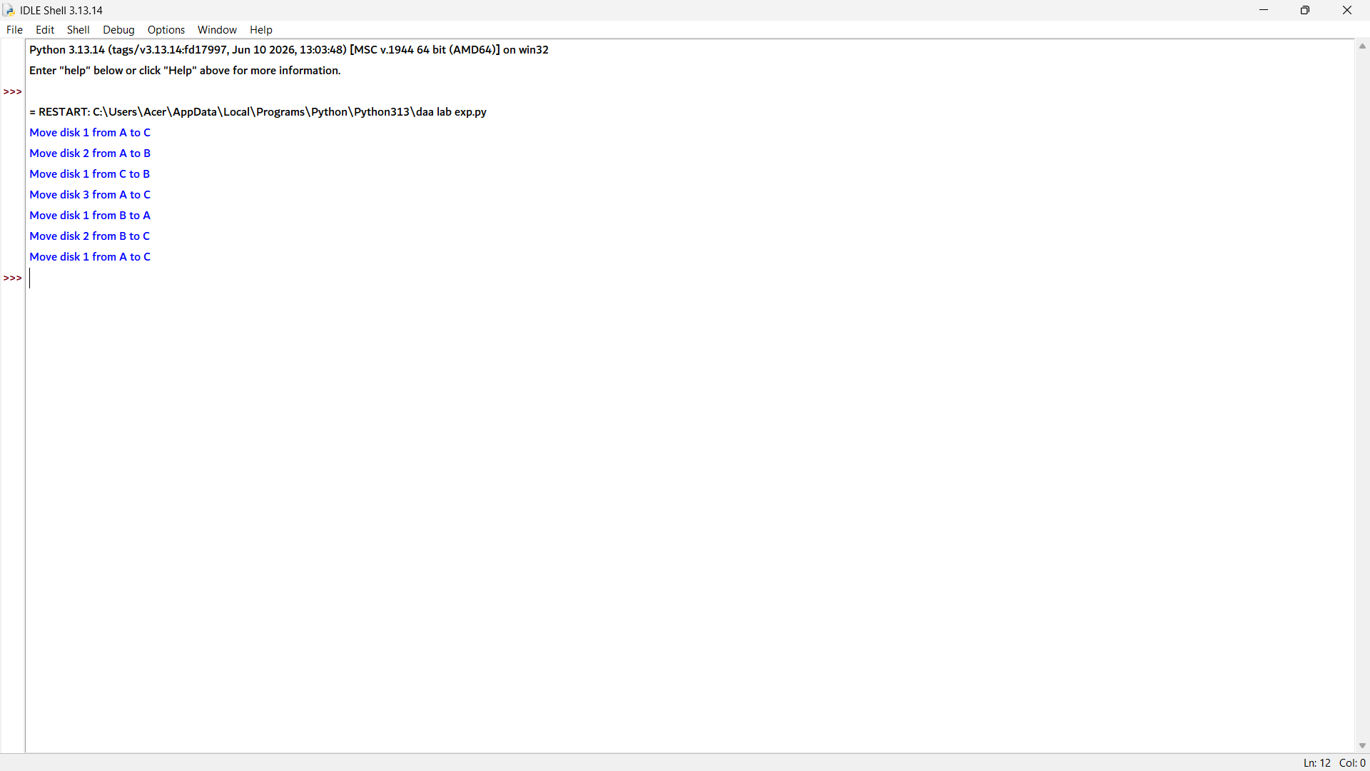

Exp 9:
def gcd(a, b):
if b == 0:
return a
return gcd(b, a % b)

a = 48
b = 18

print("GCD =", gcd(a, b))

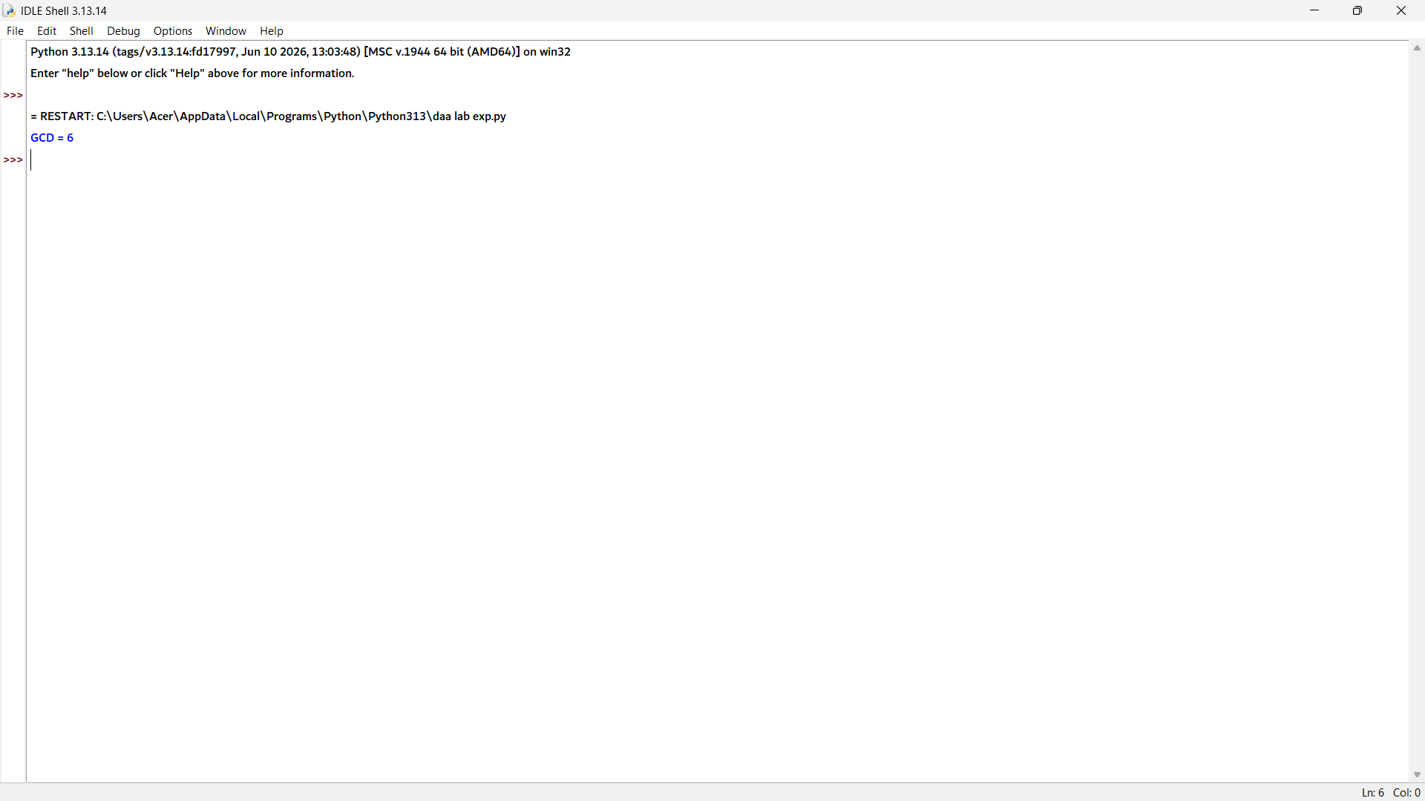

Exp 10:
arr = [12, 11, 13, 5, 6]

for i in range(1, len(arr)):
key = arr[i]
j = i - 1

while j >= 0 and arr[j] > key:
arr[j + 1] = arr[j]
j -= 1

arr[j + 1] = key

print("Sorted Array:", arr)
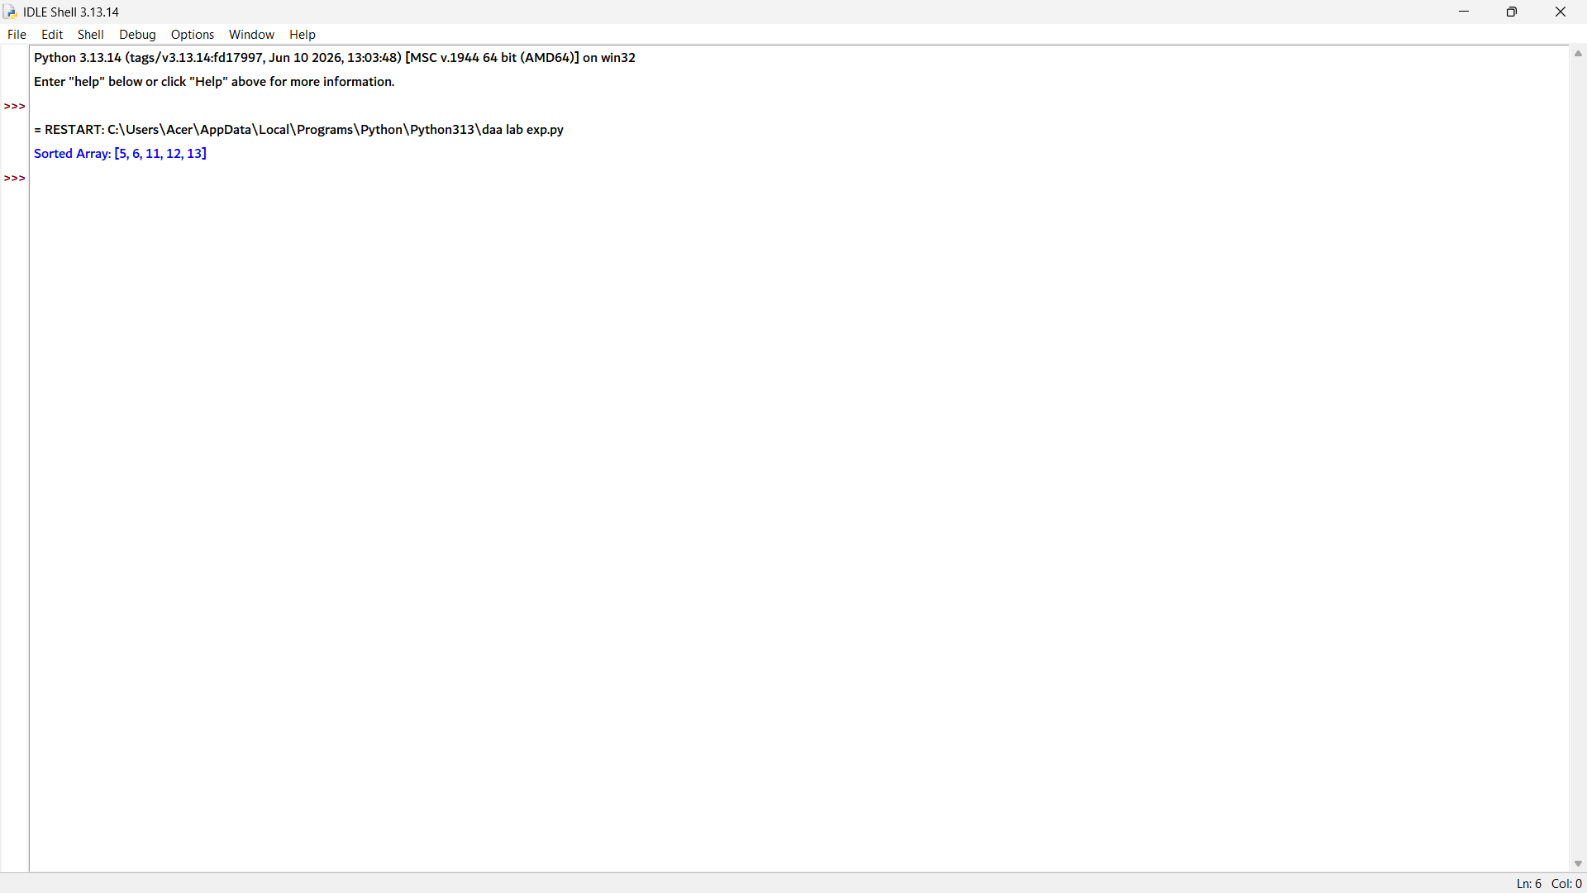

Exp 11:

def heapify(arr, n, i):
largest = i
left = 2 * i + 1
right = 2 * i + 2

if left < n and arr[left] > arr[largest]:
largest = left

if right < n and arr[right] > arr[largest]:
largest = right

if largest != i:
arr[i], arr[largest] = arr[largest], arr[i]
heapify(arr, n, largest)

def heap_sort(arr):
n = len(arr)

for i in range(n // 2 - 1, -1, -1):
heapify(arr, n, i)

for i in range(n - 1, 0, -1):
arr[0], arr[i] = arr[i], arr[0]
heapify(arr, i, 0)

arr = [4, 10, 3, 5, 1]

heap_sort(arr)

print("Sorted Array:", arr)

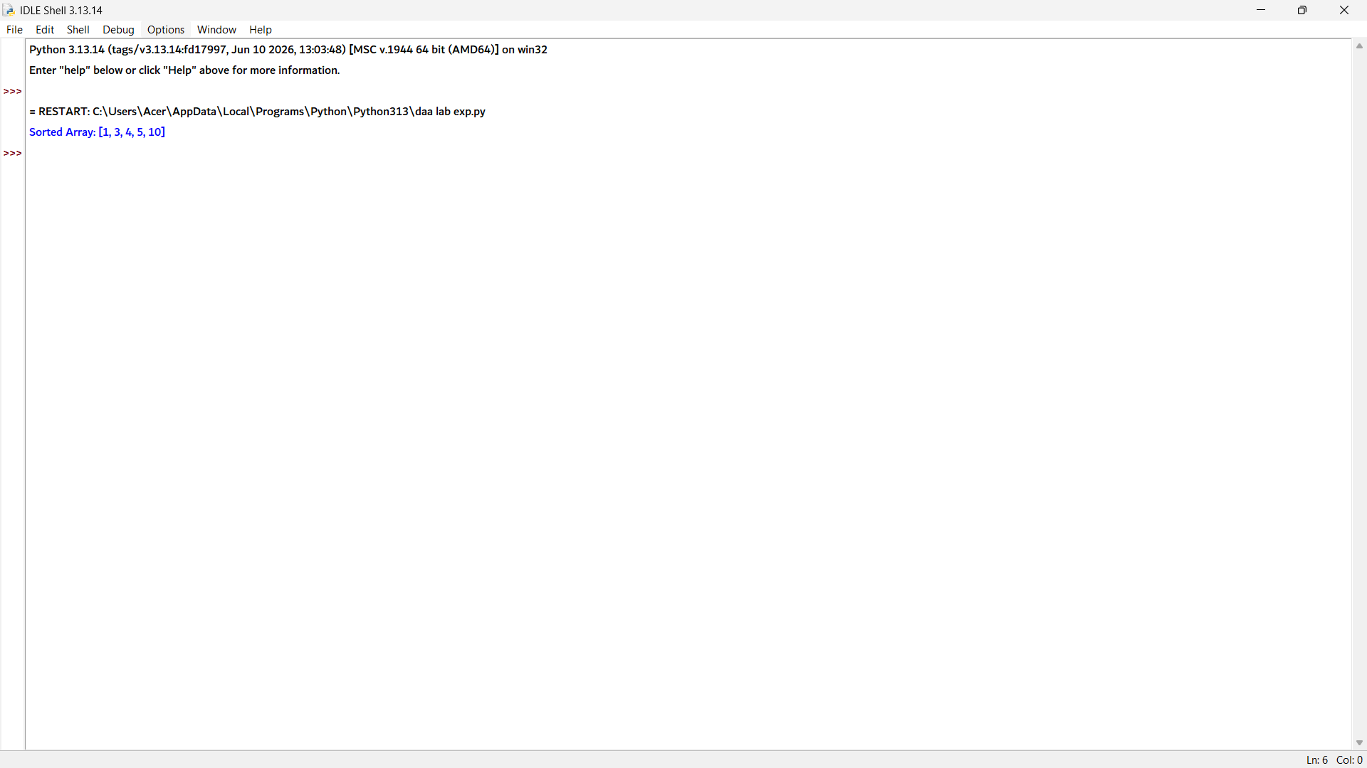

Exp 12:
def merge_sort(arr):
if len(arr) <= 1:
return arr, 0

mid = len(arr) // 2

left, inv_left = merge_sort(arr[:mid])
right, inv_right = merge_sort(arr[mid:])

merged = []
i = j = 0
inv_count = inv_left + inv_right

while i < len(left) and j < len(right):
if left[i] <= right[j]:
merged.append(left[i])
i += 1
else:
merged.append(right[j])
inv_count += len(left) - i
j += 1

merged.extend(left[i:])
merged.extend(right[j:])

return merged, inv_count

arr = [2, 4, 1, 3, 5]

sorted_arr, inversions = merge_sort(arr)

print("Number of Inversions:", inversions)

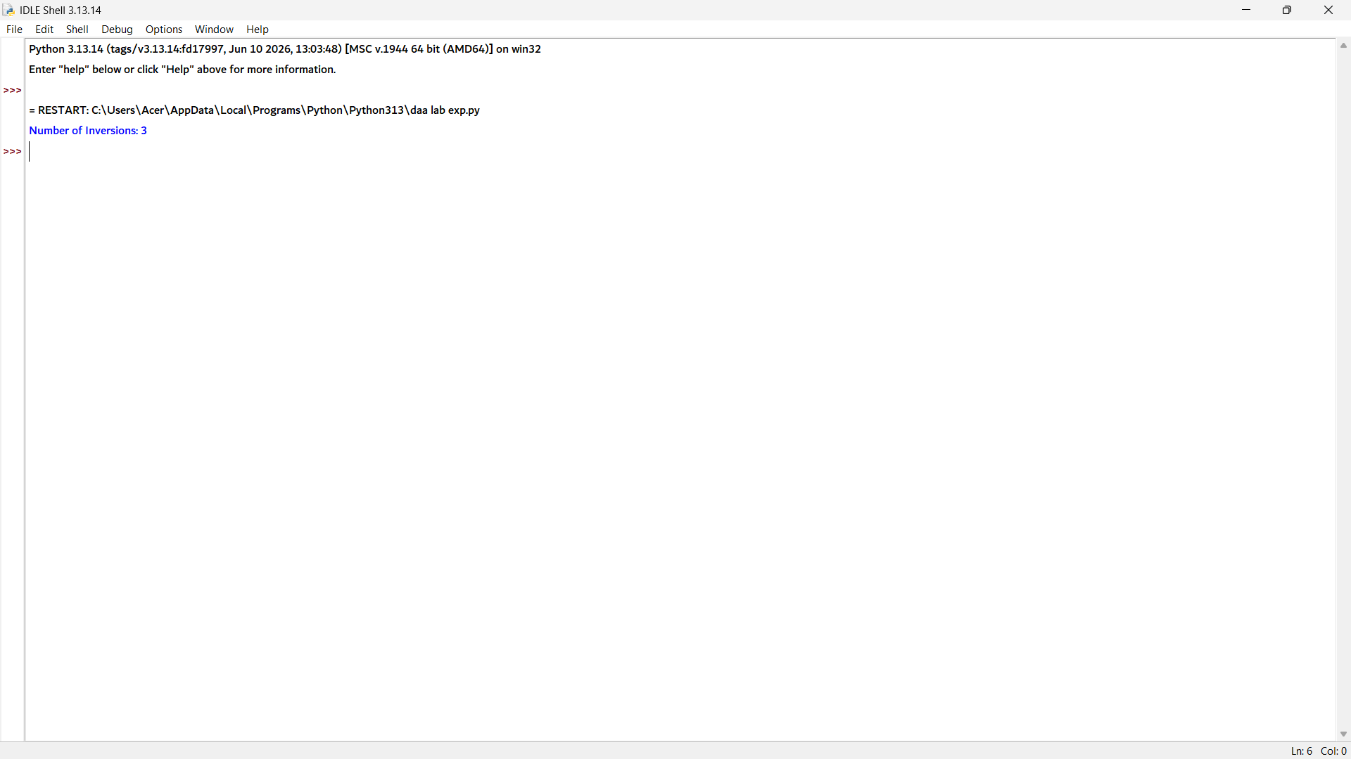

Exp 13:

arr = [-2, -3, 4, -1, -2, 1, 5, -3]

max_sum = arr[0]
current_sum = arr[0]

for i in range(1, len(arr)):
current_sum = max(arr[i], current_sum + arr[i])
max_sum = max(max_sum, current_sum)

print("Maximum Subarray Sum:", max_sum)

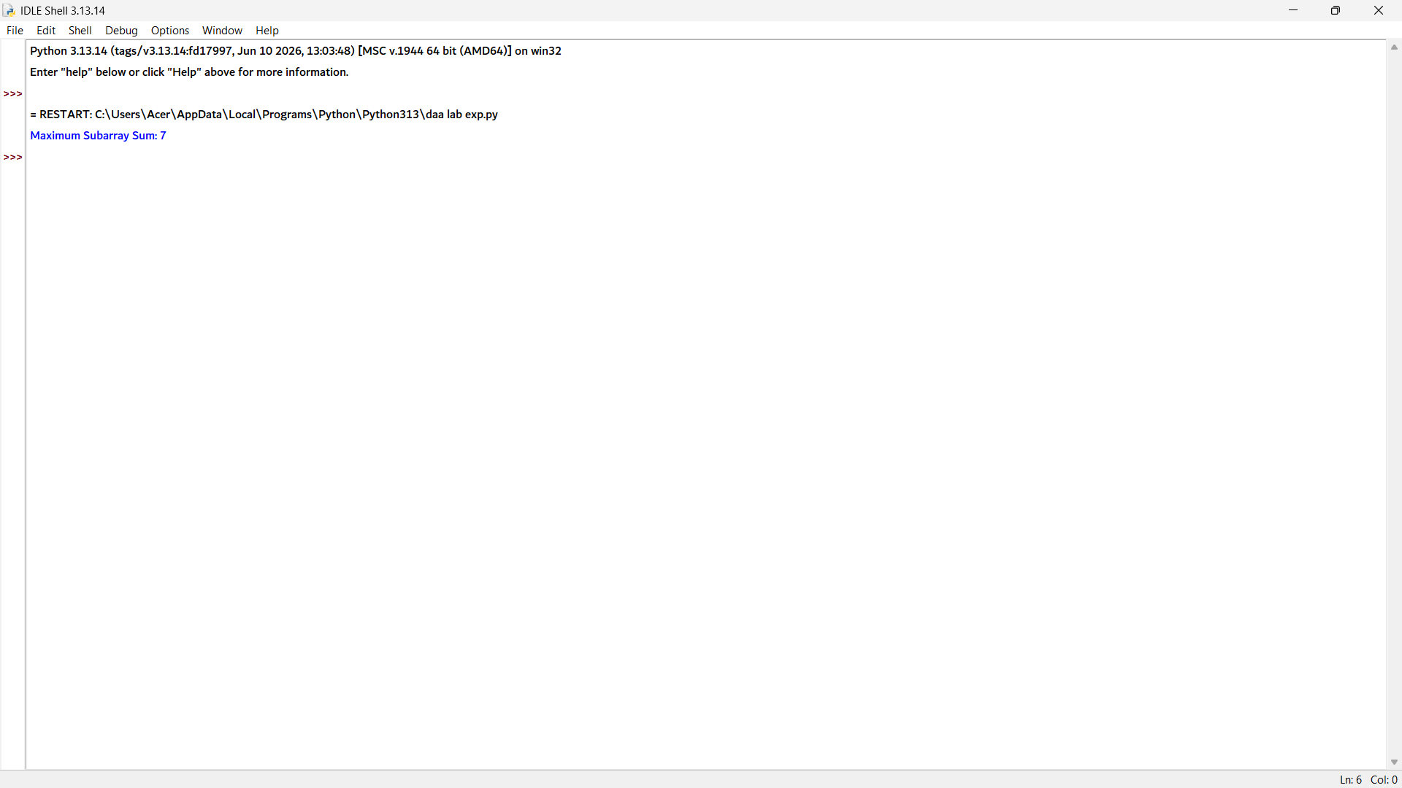

Exp 14:
# Iterative Method
def power_iterative(x, n):
result = 1
for i in range(n):
result = result * x
return result

# Recursive Fast Power Method
def power_recursive(x, n):
if n == 0:
return 1

half = power_recursive(x, n // 2)

if n % 2 == 0:
return half * half
else:
return x * half * half

x = 2
n = 10

print("Iterative Power:", power_iterative(x, n))
print("Recursive Fast Power:", power_recursive(x, n))

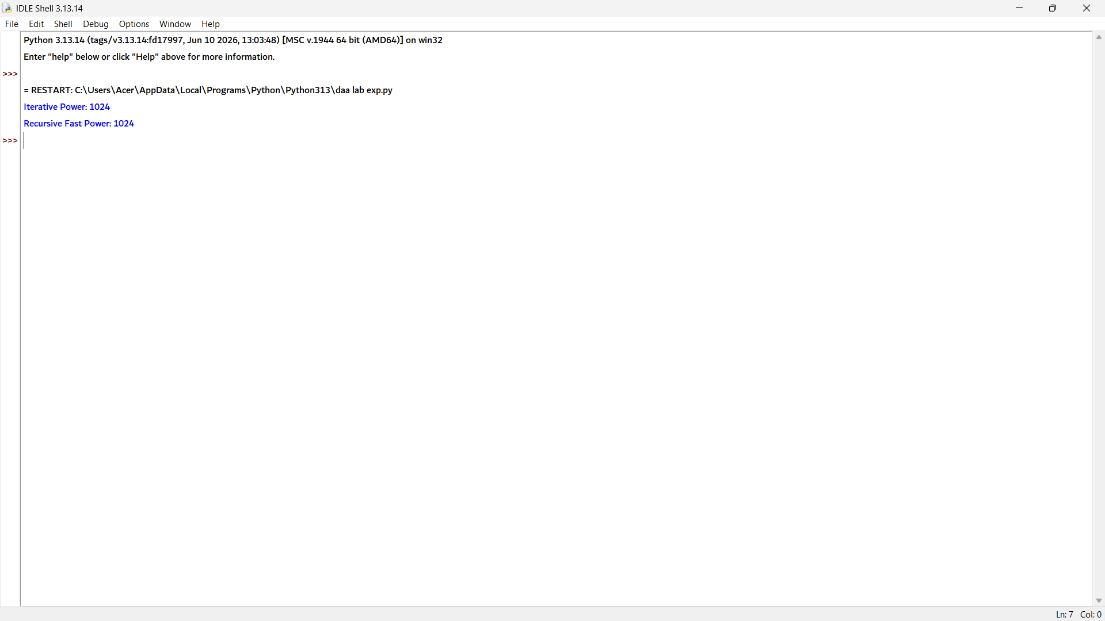

Exp 15:
import math

points = [(1, 2), (4, 5), (7, 8), (3, 1)]

min_dist = float('inf')
closest_pair = ()

for i in range(len(points)):
for j in range(i + 1, len(points)):
x1, y1 = points[i]
x2, y2 = points[j]

dist = math.sqrt((x2 - x1) ** 2 + (y2 - y1) ** 2)

if dist < min_dist:
min_dist = dist
closest_pair = (points[i], points[j])

print("Closest Pair:", closest_pair)
print("Distance:", min_dist)

